Ceredo, WV  SEPTEMBER 2026

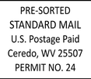

VOLUME 36, NUMBER 3

Autumn’s Quiet Magic
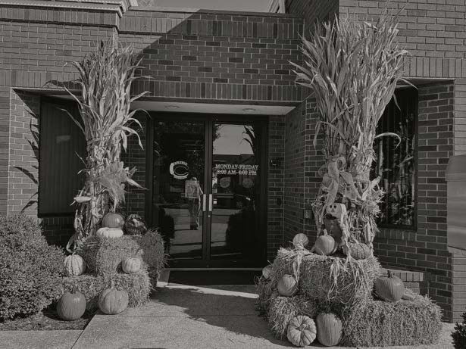
There is something special about autumn in a small town.

Perhaps it is the slower pace, the familiar faces, or the way the changing seasons seem to bring neighbors together. In Ceredo, West Virginia, fall arrives not with great fanfare, but with a quiet beauty that unfolds day by day. The morning air turns crisp, porches fill with pumpkins and mums, and shades of gold, orange, and crimson begin to paint the hills that surround our community.

For those traveling along Interstate 64, Ceredo may first appear as a charming riverside town nestled against the backdrop of West Virginia’s rolling landscape. Yet those who take the time to exit and explore soon discover something more—a place where history, community, and natural beauty come together in every season, but perhaps never more wonderfully than in the fall.

At the heart of this beauty is the Paul T. Billups Memorial Park, a gathering place that perfectly captures the spirit of Ceredo. Families stroll the walking trail beneath colorful trees, children play in the open spaces, and neighbors pause to visit while enjoying the cool autumn air.

The park- with its amphitheater, veterans memorial, and recreational areas- has become a centerpiece of community life and a place where generations create lasting memories.

.
Autumn has a way of reminding us to appreciate simple things: the sound of leaves rustling in the breeze, the excitement of community festivals, the warmth of a shared conversation, and the beauty that surrounds us every day. In a world that often feels hurried, small towns like Ceredo offer a welcome reminder that some of life’s greatest treasures are found close to home.

As another fall season settles over our valley, those who call Ceredo home know that this little town holds a beauty that cannot be measured only by scenery. It is found in the people, the traditions, and the pride that residents carry for their community. Whether arriving from Interstate 64 or walking beneath the trees at Billups Park, visitors and residents alike can discover what generations have known: autumn in Ceredo is not simply a season—it is a feeling.

And perhaps that is the true magic of fall in a small town.


CEREDO, WV SEPTEMBER 2026
The New Crescent

JULY MINUTES
The Town Council of the Town of Ceredo met in regular session on Monday, July 6, 2026, at Ceredo City Hall. Mayor Paul Billups called the meeting to order at 6:30 p.m. Council members present were Steve Diamond, Joe Ratcliff, Scott Byard, and Oscar Adkins. Also in attendance was Treasurer Robert Leslie. Councilman Steve Diamond led those present in the Pledge of Allegiance.

Reading and Approval of the Minutes

Mayor Billups asked if there were any additions, corrections, or deletions to the minutes of the June 1, 2026, Regular Session. None being heard, Steve Diamond made a motion to approve the minutes as presented. The motion was seconded by Scott Byard. All were in favor; the motion carried.

Treasurer’s Report

Treasurer Robert Leslie presented the account balances and expenditures for the month of June 2026. Mayor Billups asked if there were any questions regarding the Treasurer's Report. None being heard, Oscar Adkins made a motion to approve the report as presented. The motion was seconded by Joe Ratcliff. All were in favor; the motion carried.

Old Business

A second reading of the Election Conformity Ordinance was conducted by Oscar Adkins. Following the reading, Scott Byard made a motion to adopt the ordinance. The motion was seconded by Steve Diamond. All were in favor; the motion carried. The ordinance will be forwarded to the Wayne County Voting Coordinator for recording.

New Business

A resident submitted a request to have a sycamore tree trimmed. Following discussion, it was determined that the tree is located on railroad property and is therefore the responsibility of the railroad. Town Clerk Rachel Grant will contact the district manager to determine whether the railroad would be willing to trim the tree.

Building Inspector Todd Darst reported that the Unsafe Housing Commission agreed that the structure located at 115 Goodwill Road should be demolished following repeated requests to the property owner, as the structure has been determined to be unsafe. During the public comment period, there was no discussion and no representative for the property owner was present. The property will now be advertised for demolition bids.
Mr. Darst also notified Council that requests for inspection of the property located at 550 B Street have been ignored. As a result, the property is scheduled to be presented for further action at the next Unsafe Housing Commission meeting.

Adjournment

There being no further business, the regular meeting was adjourned at 6:39 p.m.


The New Crescent

C-K ALUMNI BAND CONCERT
The Ceredo-Kenova (C-K)
Alumni Band has been a staple in our community for many years. People gather in July to hear beloved patriotic tunes, and in December they sing along to their favorite Christmas carols.
This fall join the festivities as the C-K Alumni Band presents their Autumnfest Concert. Hits from the Big Band Era will fill the Ceredo Wellness Center on Sunday, October 25th, starting at 2:00 PM. Bring your friends and family on down and clap along as the band puts on another unforgettable concert for our community!


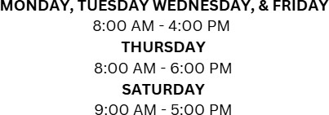

The New Crescent


Wayne County Taxes
It’s that time of year again, and tax tickets are being delivered. Our Wayne County Tax and Assessor’s Extension Office at Ceredo Town Hall is happy to answer all your tax-related questions.

The extension office handles tax and dog tag payments, affidavits, registration and license plate sticker renewals, and Homestead Exemptions.

The extension office is open on Mondays and Tuesdays from 8:00 AM – 4:00 PM. Registration stickers are available on Mondays after 12:00 and all day on Tuesdays. (Please note that the office is closed for lunch from 11:00 AM – 12:00 PM on Mondays and from 12:00 PM – 1:00 PM on Tuesdays.)

For questions outside of the extension hours, please contact the county offices:



Wayne County Tax Office 304-272-6723 Wayne County Assessor Office at 304-272-6352.

The New Crescent
About the Author - Anna Jarrell
Anna Jarrell, a lifelong resident of Ceredo, is the town’s utility clerk, assistant court clerk, and one of the monthly writers for the New Crescent. A 2025 graduate from Marshall University, Anna obtained two Bachelor of Art degrees in Professional Writing and Literary Studies as well as two minors in Creative Writing and Communication Studies.
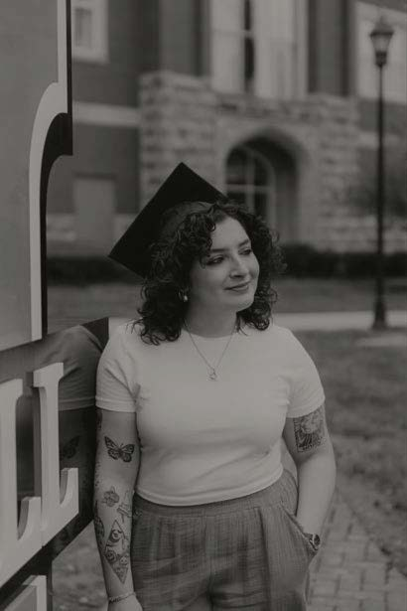
During her time at Marshall, she received English Student of the Year, Professional Writing Major of the Year, and was a member of the Student Advisory Board for the English Department. Anna is the winner of the Highest Achievement Award in Poetry, a member of the Sigma Tau Delta English Honor Society, and is a 6x Maier Writing Award nominee. Her academic writing has been presented at multiple conferences including the COLA (College of Liberal Arts) Conference at Marshall and the National Undergraduate Conference at Weber State University in Ogden, Utah.

In addition to her publications with the New Crescent, Anna’s poems and academic articles can be found in literary magazines including Et Cetera, Oswald Review, and 30North. Her copyediting work has also been featured in novels and novellas for Mountain State Press as well as local authors in the tri-state area.


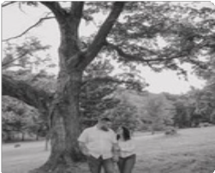

When she is not working, Anna can be found sharpening her piano skills, volunteering at her church (FBC Ceredo), and playing trumpet in the C-K alumni band. She also enjoys spending time with her family, her precious dog Chica, and her loving fiancé Nick. Anna is so excited to be writing for the New Crescent and sharing her love for the written word with all of Ceredo!

The New Crescent

Who says, “You can never go home again.”

by Mike Watts
In the summer of 1957, I was nine years old and living in Huntington with my parents, Charley and Dorothy Watts, and my three-year-old sister Vicki. As in most summers, I spent two weeks with my grandparent Watts on Big Lynn Creek and attended Vacation Bible School at East Lynn Baptist Church. When my mom and dad picked me up after the two weeks were over, we did not go back to Jefferson Avenue in Huntington but to 350 First Street East in Ceredo. How my life changed (for the better) that day. Even though I was not born in Ceredo, I have and will always consider myself “a son of Ceredo.”
I was born at St. Mary’s Hospital in 1948 but lived in Genoa through the second grade. In fact, I attended Genoa Elementary where Opal Vinson taught grades 1-6 in one room and Mrs. Patrick taught grades 7-8 in the other room. The only heat in each room was a big “pot-bellied stove.” My daughter Sarah had only heard of this type of school and never knew her dad attended one. She also found it hard to believe we never had indoor plumbing during this time.

Because of health issues in recent years, I return “home” only every couple of years. This year marked the 60th anniversary of my 1966 graduation from CKHS. My wife, Susan (Neale), also graduated in 1966, but from Huntington High School (HHS). Her class planned a large reunion that she wanted to attend. Knowing this, some of my classmates organized an informal reunion of the 1965 CKHS football team—Coach Ward’s first undefeated AA State Championship team. So, Susan and I decided it was time to “go home again,” especially since we would also celebrate our 56th wedding anniversary during the trip. We also decided to bring our daughter, Sarah, with us so she could see just where and how her dad grew up and to also meet some of his very best friends.
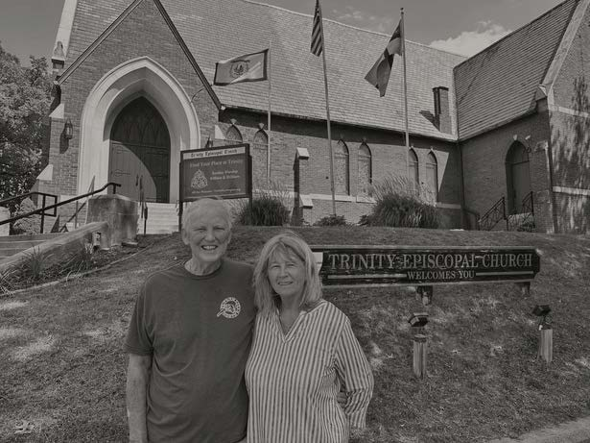
Our trip started on August 19th flying from OKC to The Tri-State Airport with stops at DFW Dallas and Charlotte. The following is a brief recap of where we went and what we did over the next five days.

Day 1 - Midway Drive-In for hot dogs and root beer. Visited my friend Mayor Paul Billups. Paul and I go back from our Little League baseball days at Mitch Stadium, to playing a charity football game at the old Fairfield Stadium for the Huntington Police Department. We were well past our prime at that time.
I told Paul that I consider myself “the unofficial and un-elected Ceredo Councilman at Large – West of the Mississippi.” That evening Susan and I had dinner with our family at Rocco’s. We were lucky, and Rocco was playing saxophone for his customers.

The New Crescent

Who says, “You can never go home again.” continued...
Day 2 - This evening we had the CKHS ’65 football reunion at the Marshall Café. Big thanks to Molly, Jennifer, Mary Anne and Sherry who were the organizers. It was great seeing Dave Lucas, Dave Ferguson, Danny Shannon, Whitey Null, Dennis Frasher, and Charles “Nip” Evans again – they were great players and even better friends. There is some debate as to which was the greatest CKHS football team of all time – some say the 1965 team, some say the 1994 team – you decide. They were both great teams.

Day 3 - The day started at Virginia Point in Kenova, which is a beautiful park now, but I remember when it was the Kenova dump. I used to go shoot rats with my .22 rifle with my buddies. Next stop was the Ramsdell House (built in 1858), then on to the Town of Ceredo Museum where we spent two wonderful hours reliving Ceredo history. If you haven’t visited this wonderful museum, you need to do so.
The highlight of the day was stopping at the Griffith and Feil Drugstore for lunch. I’ve known Ric Griffith since Little League and knew that he had retired as a pharmacist. I talked to his daughter, Heidi, who now runs the pharmacy, and she said Ric was not around that day. Bummer, I thought I had missed seeing Ric this trip, but “surprise-surprise Sgt. Carter”, about 15 minutes later Ric walks in the door. Heidi had been very thoughtful and had called her dad and told him we were asking for him. Ric sat down and talked with us during lunch and invited us to come back to the Pumpkin House with him.
Thousands of people worldwide have seen the Pumpkin House on various national TV shows in its decorated and lighted Halloween glory, but few have seen the hundreds of historical and entertaining artifacts inside its walls. We now have seen many of them, and they are wonderful.

Day 4 - Big day for us – August 22nd – was our 56th wedding anniversary. We relived this day by taking a photo in front of the church where we were married – Trinity Episcopal Church. We had lunch at the Frostop Drive-In and ice cream at Austins in Ceredo. This was the night of Susan’s HHS class reunion, and she got to visit with many of her friends and classmates.

Day 5 - This day proved to be a revelation for my daughter Sarah. She is used to the city streets and four lane highways in Oklahoma. If you have ever personally driven the roads to Big Lynn Creek and East Lynn, you certainly understand how nervous she became on the way to where my dad grew up. Sarah now knows what a “kiss your a** curve” is. Her hands were literally sweating, and she kept asking me to turn around and go back to Ceredo. We made it there and came back safely, but she said she never again wanted to take that drive into the “hollers” of Wayne County, no matter who grew up there!

Day 6 - We spent most of our last day in town with Susan’s two sisters that live in Huntington. I did take Susan and Sarah to the legendary Mitch Stadium, where I spent hundreds of hours as a kid playing Little League and “pick-up” baseball games with my buddies. Our last stop was to say goodbye to Paul and Kathy Billups. We also wanted to say goodbye to Doug Adkins, a long-time special friend of mine and my parents. This was a great trip for me and my family – one that we will always remember.

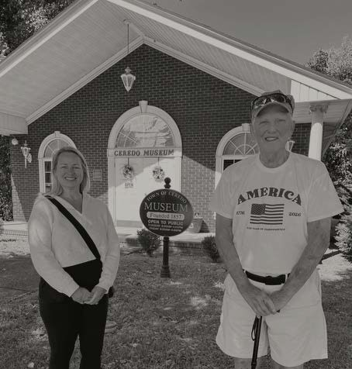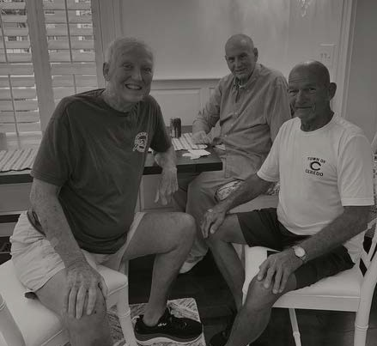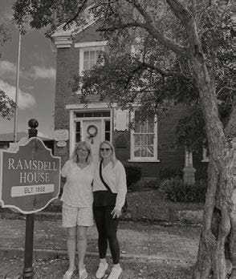

The New Crescent

Employee of the Month

Sergent Eplion, Ceredo Police Department
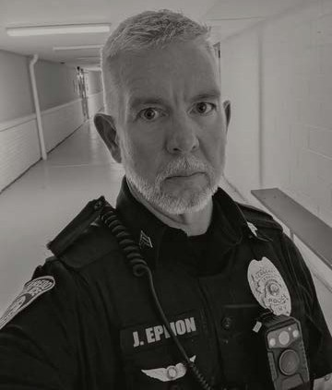

“The pig did loudly protest its detainment and was unable to provide identification.”
Sergeant Jared Eplion has been a faithful officer of the Ceredo Police Department for over three years. His loyalty to the town and dedication to his work are evident in how he conducts himself on the job. Jared knew from a young age that he wanted to go into law enforcement. “My mom was a victim of domestic violence,” he recalls. “I remember when I was in middle school, calling the cops for my mom and waiting over 2 hours for them to show up.” From that point on, he knew he wanted to be the change.
However, it was not until Jared was 45 that he joined Ceredo’s team. Unable to previously pass the physical test, Jared claims that going through the academy at his age is one of his greatest accomplishments. He is also proud to be working for the same department that his grandfather did. “My grandpa was interim chief in ’99 until Jack Butcher took over, so it just felt like the right choice,” he shares. Jared also says that Ceredo allows him to set his own pace. “We’re able to be proactive rather than just having to answer calls,” an advantage that comes from being in a smaller town.
Proactive policing stops crime before it happens, leading to Ceredo’s low crime rate.

Though the job is stressful, there are many fond moments that make it worth it. One of Jared’s favorite memories took place on Saturday, July 19, 2025. At approximately 6:50 in the morning, he received a call so humorous, it could almost be a prank. A pig was fleeing down Main Street! Once he received the call, it was time to act. After multiple failed attempts to capture the animal – and multiple chases down the road – the pig was apprehended and placed into the back of Jared’s patrol vehicle. According to the narrative for the assigned case (number 25-07155IR), “The pig did loudly protest its detainment and was unable to provide identification.” It was then driven to the Farmer’s Market where Mr. Jason Ekers provided a cage and care for the animal until the situation was resolved. “I felt so silly,” Jared laughs. “I was a pig chasing a pig!”

The New Crescent

Honoring Those Who Served

An Interview with Frank Warren
Arnold “Frank” Warren is a familiar face to all who attend the Ceredo Wellness Center regularly. Working the afternoon shift, he provides help and guidance to those looking to improve their physical fitness. However, Frank has not always worked at our local gym. For 24 years, he served in the United States Air Force, learning and building skills that would translate into his civilian life.
Frank joined the Air Force in March of 1978, right after he turned 18. He chose this branch because it offered more technical training and fantastic educational opportunities. So, while others were graduating high school, Frank was off to basic training.

As with most veterans, basic training came as a complete shock. “The first thing I saw was total complete discipline, and I was an undisciplined teenager,” he laughs. They asked the recruits to perform seemingly mundane tasks, but each one served a purpose: they instilled the importance of listening to orders and instruction. Assignments such as mindlessly lifting and dropping bags taught the recruits to not question authority and respond to orders without hesitation. Self-discipline was one of the main virtues Frank learned during his time in the service, and it is now central to his makeup.
Frank held many titles throughout his military career, but his main occupation was that of aerospace ground equipment (AGE) technician. AGE technicians are jacks of all trades who support all the systems on an aircraft, making sure the plane is ready to fly.

The last three years of his career, however, he was the maintenance squadron production superintendent where he directed aircraft maintenance specialists in support of flightline operations. When problems arose, he was in charge of dispatching units to fix said problems. “In this position, you can’t be hesitant; you have to be decisive,” Frank says. “Those were my favorite three years in the Air Force because they were so intense and rewarding.”

Frank received many awards during his time in the service. Some of his most rememberable include the NCO (non-commissioned officer) Leadership Award voted on by his peers in 1987, and the Senior NCO of the Year Award right before his retirement in 2002.

When returning to civilian life, he found that the military had more prepared him for civilian life. His multiple jobs provided him with both technical and personnel skills that could translate into any workforce. “I could do anything and work for any company. [The military] enabled me to do all kinds of things,” he says. The Air Force also provided him with the education he sought after. He obtained both an Associate Degree in Aerospace Ground Equipment Technology and a Bachelor of Science in Business Information System, which is part of the reason he enjoys working with computers and systems central to the Wellness Center. “I can work on the machines and help people,” which to Frank, is not really a job but a pleasure.

The New Crescent

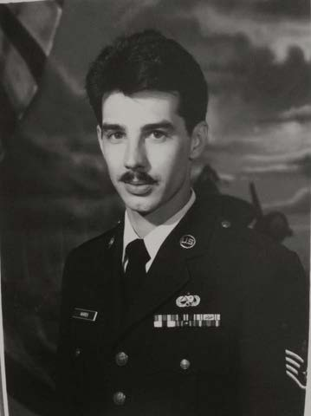
Honoring Those Who Served

An Interview with Frank Warren continued...
Staying on bases stretching from California and Texas to Germany and Korea, the Air Force fostered a love for the military in Frank Warren. “All men should do at least a couple years in military service,” he says. “It taught me self-discipline and compassion,” a skill he exercises regularly working at his job and teaching his Sunday school class. The Air Force was a large part of Frank’s life and gave him opportunities that otherwise he might not have received. It taught him invaluable lessons and made him who he is.

Employee of the Month

Seargent Eplion, Ceredo Police Department continued...

While there sure are some funny moments in a town Ceredo’s size, the well-being of our residents is our department’s primary focus. The Ceredo Police Department prides itself on integrity, responsiveness, and proactivity – all of which Jared demonstrates and prioritizes. His specialties in interdiction and technology keep our streets safe and the department running.
Sergeant Jared Eplion is an imperative member of our team, and it is men like him who make Ceredo a safe home to many.

D I S C O V E R T H E S T O R I E S T H A T
B U I L T O U R

C O M M U N I T Y

The Town of Ceredo YouTube Channel features fascinating stories, local history, historic photographs, community landmarks, and the people who helped shape our town.
Whether you're a lifelong resident, a former neighbor, or simply love local history, there's something waiting to be discovered.
Watch, subscribe, and share!
Visit: youtube.com/@TownofCeredo

The New Crescent
Upcoming Events:

October 25, 2026
CK Alumni Band Concert 2pm, Ceredo Wellness Center

October 22-31, 2026

Early voting

October 22-31, 2026
C-K Autumnfest
October 31, 2026 6pm-8pm CCeredo Trick-or-Treat NNoovveemmber 7, 2026 Noon
CC--KK VVeterans Day Parade





Breakfast Parfait
Ingredients:
(Note: I did not list the amounts because they will vary according to the size of the serving dish and the amount of servings.)
Peach Yogurt Sliced Bananas
Blueberries (fresh or thawed frozen) Kashi Toasted Berry Crisp Cereal Honey

Directions:
Place a layer of cereal in dish, add a layer of yogurt, top with bananas and blueberries and repeat; drizzle with honey. Serve immediately.
THE CRESCENT KITCHEN
by Natalie Hemann
Several years ago, my husband and I stayed at a quaint inn in Ohio. One of the items available at breakfast was a parfait. I had not thought about this dish until the other day when I was buying yogurt at the grocery store. I bought everything I needed to try and recreate this parfait at home, and I was pretty happy with the results. The best thing about this recipe is that you can customize it by using all your favorite ingredients.

You can see my favorites to the left, but I’m sure your favorites will be just as delicious!


The New Crescent

SERVING CEREDO, WEST VIRGINIA

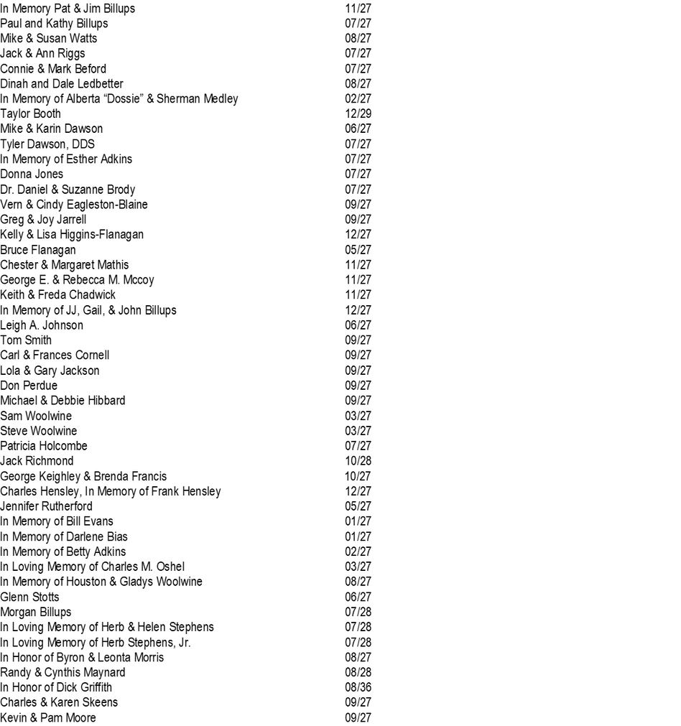
A very special "Thank You!" to all of you who have helped us to continue the paper with your gifts.
Honor Roll

With your help, we have been able to publish and deliver The New Crescent to every home in Ceredo since February 1990!

If you would like to add your name or a loved one’s name, please contact Town Hall at (304) 453-1041 or email: info@ceredowv.gov.

Upcoming Town Hall Closures:
November 3, 2026
Election Day November 11, 2026 Veterans Day November 26, 2026 Thanksgiving Day

Articles written by:
Anna Jarrell &
Rachel Grant unless otherwise noted

